https://www.javatpoint.com

Home

Java

Programs

OOPs

String

Java Tutorial 💻⌨️

What is java🖥🖥

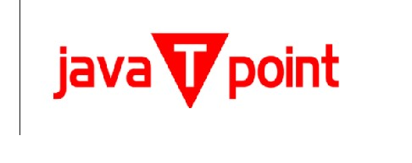

Splunk

Swagger

Transact - SQL